Jammu and Kashmir

1. **Gurez Vally**

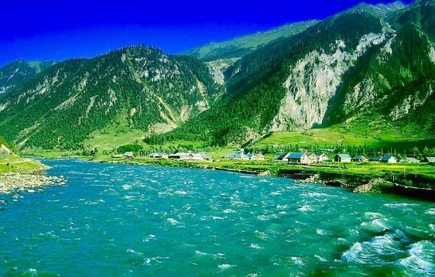 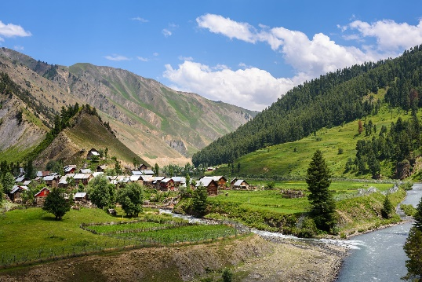

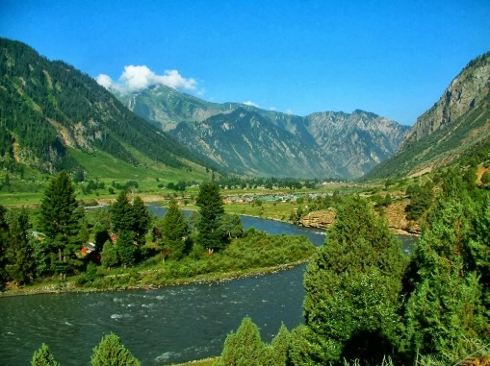

Gurez Valley, also known as Gurais Valley, is one of the most picturesque and least explored regions in Jammu and Kashmir. Nestled in the high Himalayas, about 123 kilometers from Srinagar, Gurez Valley lies along the Kishanganga River. The valley is characterized by its lush meadows, dense forests, snow-capped peaks, and the unique cultural heritage of the Dard-Shin people who inhabit the region.

Historical Background

1. Ancient Significance:

- Gurez Valley has a rich historical and cultural heritage, with its roots tracing back to ancient times. It was part of the ancient Dardistan region, home to the Dards, an Indo-Aryan ethnic group. The Dard people are mentioned in several ancient texts, including the Mahabharata and the works of Herodotus, the Greek historian.

2. Strategic Location:

- The valley's strategic location made it an important trade route between Kashmir and Gilgit-Baltistan. It was part of the ancient Silk Route, facilitating the movement of goods and culture between Central Asia and the Indian subcontinent.

3. Cultural Heritage:

- The people of Gurez, known as Dard-Shin, have a distinct culture, language, and traditions. They speak Shina, an ancient Dardic language, and have preserved their unique cultural identity despite the influences of neighboring regions.

4. Islamic Influence:

- Like much of Kashmir, Gurez Valley saw the spread of Islam during the medieval period. Sufi saints and traders played a significant role in the spread of Islam in the region, and the valley is home to several Sufi shrines.

Modern History

1. Indo-Pakistani Conflicts:

- Gurez Valley's proximity to the Line of Control (LoC) between India and Pakistan has made it a strategically sensitive area. During the Indo-Pakistani wars of 1947-48, 1965, and 1971, the valley witnessed military activity and remained on high alert.

2. Military Presence:

- Due to its strategic importance, the Indian Army maintains a significant presence in Gurez Valley. This has led to restricted access and limited tourism development in the region until recent years.

Notable Attractions in Gurez Valley

1. Habba Khatoon Peak:

- Named after the famous Kashmiri poetess Habba Khatoon, this pyramid-shaped peak is one of the most prominent landmarks in the valley. The poetess is said to have wandered the valley in search of her lost love, Sultan Yousuf Shah Chak.

2. Kishanganga River:

- The crystal-clear waters of the Kishanganga River flow through the valley, offering opportunities for fishing and riverside picnics.

3. Razdan Pass:

- The pass is the gateway to Gurez Valley, offering breathtaking views of the surrounding mountains and valleys.

4. Ancient Forts and Shrines:

- The valley is dotted with ancient forts and shrines, reflecting its rich history and cultural heritage.

1. **Tarsar Marsar Trek**

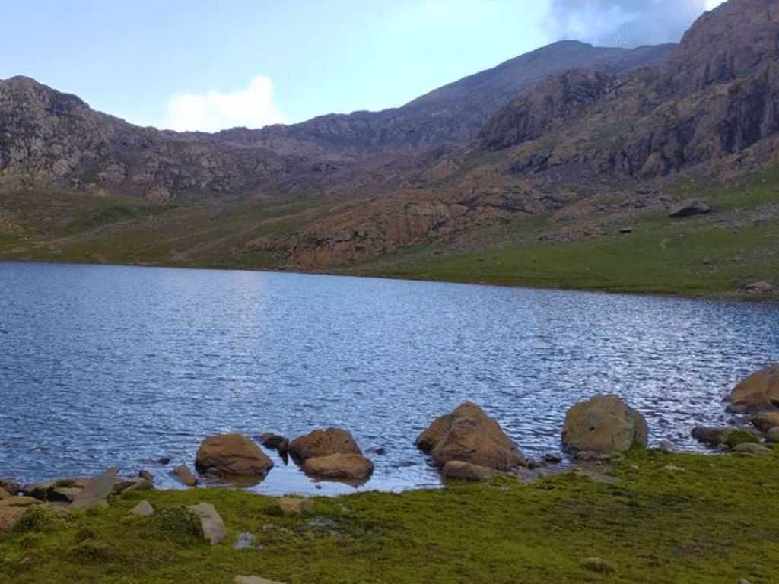 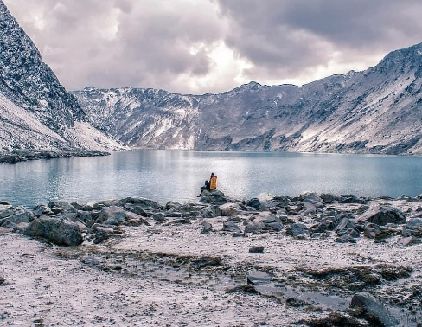

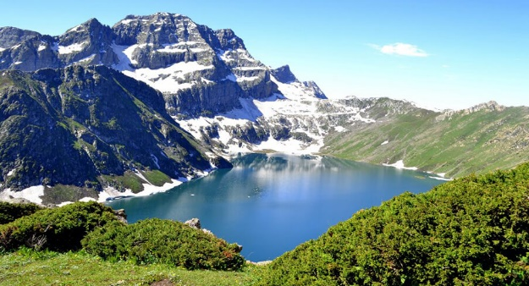

The Tarsar Marsar trek in Jammu and Kashmir is one of the most beautiful and serene treks in the region, known for its stunning alpine lakes, lush meadows, and breathtaking landscapes. The trek is named after two high-altitude lakes, Tarsar and Marsar, which are nestled in the Aru Valley of the Anantnag district.

Historical and Cultural Background

1. Ancient Significance:

- The Kashmir Valley, where the Tarsar Marsar trek is located, has a rich history dating back thousands of years. It has been a significant center of Hinduism and Buddhism before the advent of Islam. The region is known for its ancient temples, monasteries, and a deep cultural heritage.

2. Local Legends and Folklore:

- The lakes and surrounding areas are steeped in local legends and folklore. It is believed that the lakes have mystical powers and are considered sacred by the locals. The beauty and serenity of the lakes have inspired many local tales and songs.

3. Mughal Era:

- During the Mughal era, the Kashmir Valley was a favorite retreat for the Mughal emperors. They were enchanted by the natural beauty of the region, including the areas around the Tarsar and Marsar lakes. The Mughal influence can still be seen in the region's architecture and gardens.

Trekking History

1. Discovery and Popularization:

- The Tarsar Marsar trek gained popularity among trekkers and nature enthusiasts relatively recently. The pristine beauty of the lakes and the surrounding landscapes started attracting trekkers from across the globe. The trek was primarily explored by local shepherds and adventure enthusiasts who ventured into these remote areas.

2. Ecotourism Development:

- In recent years, the Jammu and Kashmir tourism department, along with local trekking organizations, has been promoting the Tarsar Marsar trek as an ecotourism destination. Efforts have been made to develop sustainable tourism practices that protect the fragile environment and benefit local communities.

The Trek Experience

1. Starting Point – Aru Valley:

- The trek typically starts from Aru Valley, a picturesque village near Pahalgam. Aru Valley itself is known for its scenic beauty and serves as a base camp for several treks in the region.

2. Tarsar Lake:

- The trek to Tarsar Lake involves passing through lush meadows, dense forests, and beautiful streams. Tarsar Lake is an almond-shaped alpine lake situated at an altitude of approximately 12,500 feet. The lake is surrounded by snow-capped peaks and lush green meadows, making it a perfect camping spot.

3. Marsar Lake:

- From Tarsar Lake, the trek continues to Marsar Lake, which is located at an altitude of about 13,000 feet. Unlike Tarsar, Marsar Lake is often shrouded in mist and clouds, giving it a mysterious and ethereal appearance. The lake is situated in a more secluded area, adding to its untouched beauty.

4. Other Highlights:

- The trek also includes exploring the Sundarsar Lake, the lush green meadows of Lidderwat, and the expansive Shekwas meadows. The entire trek offers a unique blend of diverse landscapes, from dense forests and alpine meadows to high-altitude lakes and mountain passes.

The Tarsar Marsar trek is not just a journey through some of the most beautiful landscapes in Kashmir but also a walk through the rich cultural and natural heritage of the region. It offers trekkers an opportunity to experience the untouched beauty of the Himalayas while connecting with the local history and traditions.

1. **Sanasar**